9th ASIA International Conference (Langkawi, Malaysia)
The Role of Transformational Leadership on Performance among Academic Staff in China
Midya Yousefi^{1*,}
Educational Leadership Department
Wenzhou-Kean University, No.88 Road, Wenzhou, 325060
China
myousefi@kean.edu
Jun Zhang
Educational Leadership Department
Wenzhou-Kean University, No.88 Road, Wenzhou, 325060
China
zhanjun@kean.edu
Ziwei Jiang
Educational Leadership Department
Wenzhou-Kean University, NO.88 Road, Wenzhou, 325060
China
ziweij@kean.edu
*Corresponding Author email: myousefi@kean.edu
Submitted: 17 February 2024 Revised: 19 March 2024 Accepted: 24 March 2024

Peer-review under responsibility of 9th ASIA International Conference (Langkawi, Malaysia) Scientific Committee
http://connectingasia.org/scientific-committee/
© 2024 Published by Readers Insight Publisher,
Office # 6, First Floor, A & K Plaza, Near D Watson, F-10 Markaz, Islamabad. Pakistan,
editor@readersinsight.net
This is an open access article under the CC BY license (http://creativecommons.org/licenses/4.0/).
ABSTRACT
An essential element that enhances the quality of education, particularly in terms of its impact on teaching performance in higher education, is the leadership using appropriate styles.The study, therefore, seeks to measure the impact of four pillars of transformational leadership: Idealized Influence, Inspirational Motivation, Intellectual Stimulation, and Individualized Consideration on the teaching performance of the academic staff. The sample included 290 full-time teachers from Wenzhou, China. Data were obtained through an online survey utilizing a structured questionnaire based on the theories and literature of the relevant review. AMOS was used to test the four validated research hypotheses and give a comprehensive measurement model. The study asserts that the four aspects of transformational leadership positively affect teaching performance, reflected by the four I's of transformational leadership. The current findings are beneficial to universities and assist educational leaders in gaining information on how transformational leadership dimensions may be used to influence the staff's teaching performance positively. In addition, the paper contributes to the existing corpus of research presented on the impact of transformational leadership on the teaching performance of the academic staff. Further, it informs policy and educational administrators in this area.
Keywords: Transformational Leadership; Idealized Influence; Inspirational Motivation; Intellectual Stimulation; Individualized Consideration; Academic Performance
RESEARCH HIGHLIGHTS
Positive Influence of Transformational Leadership Dimensions: The study concluded that transformational leadership positively influences teaching performance among the academic personnel of Wenzhou universities based on the four factors of transformational leadership. This finding reflects that transformational leadership is essential in developing teaching performance among faculty members, as proposed by Alzoraiki et al. (2018) and Camps and Rodríguez (2011). Identifying predictors on the other side that may influence the performance of academic staff (faculty members) in educational institutions involves examining various factors that can impact their effectiveness in teaching, research, and other professional responsibilities (Yousefi et al., 2019).
Individualized Consideration as the Most Influential Impact Factor: Among the four pillars of transformational leadership, individualized consideration surfaced as the premier indicator of enhanced teaching performance. This is to say that individualized attention and mentoring from the leaders toward faculty members could result in more inspiration from the educator's side, leading to better educational outcomes. The individualized consideration significantly reflects Chinese culture (Lin et al., 2013), where a focus on relations and mentorship at the education level is paramount.
__________________________________________________________________________________________

GRAPHICAL ABSTRACT
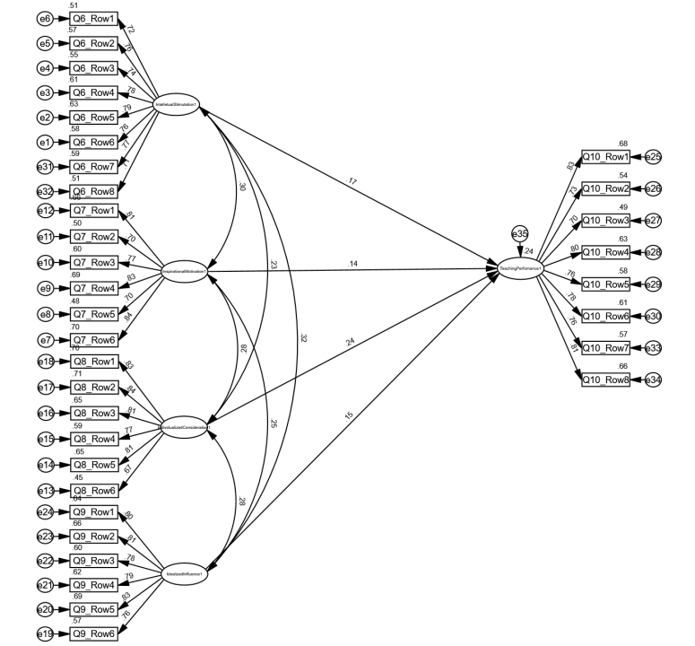
- Path Diagram of TL Dimensions and Relationships on TP
__________________________________________________________________________________________
Research Objectives
This research intends to probe the effects of transformational leadership on teaching performance among academic staff in Chinese universities in Wenzhou. This paper, in particular, seeks to establish how the four pillars of transformational leadership impact the teaching performance of faculty. The purpose of the study, therefore, would be to provide insights for educational leaders on increasing quality in teaching, as well as add to academic literature regarding leadership within an educational context.
- Does idealized influence positively affect teaching performance?
- Does inspirational motivation positively affect teaching performance?
- Does intellectual stimulation positively affect teaching performance?
- Does individualized consideration positively affect teaching performance?

Methodology
This study used an online survey to collect data from 290 full-time faculty members at three public universities in Wenzhou. A structured questionnaire was adapted from Chaoping and Kan (2008) and Moeller (2009) to quantify the elements of transformational leadership and its significance on teaching performance. Collected data was further analyzed with the help of AMOS software.
Results
The results indicated a satisfactory level of fit for the model, with the Chi-Square/df ratio (CMIN/DF) at 1.072, SRMR at 0.0401, GFI at 0.901, NFI at 0.913, CFI at 0.994, and RMSEA at 0.016, all within the recommended thresholds for a good fit. Path analysis revealed significant positive impacts of transformational leadership dimensions on teaching performance: Intellectual Stimulation (β = 0.286, p < 0.01), Inspirational Motivation (β = 0.207, p < 0.05), Individualized Consideration (β = 0.451, p < 0.001), and Idealized Influence (β = 0.249, p < 0.05).
Findings
Four of these were identified as the positive dimensions of transformational leadership that would enhance the teaching performance of the academic staff in the selected universities. Above all, the more significant dimension was individualized consideration, which manifests that particular treatment or support from leaders develops teaching performance. These findings thus indicate the importance of transformational leadership styles in enhancing higher education teaching performance, particularly in China's culturally bound country.
References
Alzoraiki, M., Rahman, O. B. A., & Mutalib, M. A. (2018). The effect of the dimensions of transformational leadership on the teachers' performance in the Yemeni public schools. European Scientific Journal, 14(25), 322. https://doi.org/10.19044/esj.2018.v14n25p32
Camps, J., & Rodríguez, H. (2011). Transformational leadership, learning, and employability: Effects on performance among faculty members. Personnel Review, 40(4), 423-442. http://dx.doi.org/10.1108/00483481111133327
Chaoping, L. I., & Kan, S. (2008). The structure and measurement of transformational leadership in China. Frontiers of Business Research in China, 2(4), 571-590. https://doi.org/10.1007/s11782-008-0032-5
Lin, L. H., Ho, Y. L., & Lin, W. H. E. (2013). Confucian and Taoist work values: An exploratory study of the Chinese transformational leadership behavior. Journal of business ethics, 113, 91-103. https://doi.org/10.1007/s10551-012-12
Moeller, C. (2009). Stressors, strains and social support: Occupational experiences of university professors. Electronic Theses and Dissertations. 40. https://scholar.uwindsor.ca/etd/40
Yousefi, M., & Abdullah, A. G. K. (2019). The Impact of Organizational Stressors on Job Performance among Academic Staff. International Journal of Instruction, 12(3), 561–576. https://doi.org/10.29333/iji.2019.12334a
Author’s Biography

Midya Yousefi is an assistant professor in the Doctorate of Educational Leadership & Master of Educational Administrative programs at Wenzhou-Kean University. She earned her Ph.D. in Educational Leadership & Management and MEd in Educational Administration & Management from the Research University of Science Malaysia. She has over nine years of experience teaching educational leadership, management, and administration courses. She has taught students from different countries. Her educational leadership roles include being the program leader of the MSc. in Education Management & head of the Centre for Leadership & Development in Malaysia. She is experienced in quantitative research methodology and facilitating statistical software workshops, including SPSS, AMOS & SmartPLS in Malaysia, the Middle East, and China. She is also an academic Academy of Management (AOM) member.

Jun Zhang is an Ed.D. candidate in Educational Leadership at Wenzhou-Kean University with dual master's degrees, including one in Mathematics, highlighting his proficiency in quantitative analysis. His extensive experience in finance complements his academic pursuits, creating a blend of skills in both numeracy and leadership. Jun Zhang's research interests primarily focus on leveraging quantitative methodologies to explore various dimensions of educational leadership. His interdisciplinary approach enriches his contributions to understanding and enhancing leadership dynamics within academic settings.

Ziwei Jiang is an Ed.D. candidate in Educational Leadership at Wenzhou-Kean University, also with an Educational Management master's degree. The continuous study of education has enriched Ziwei Jiang’s cognition of different theories in the field of education and supported more in-depth research. Ziwei Jiang's research interests mainly focus on using quantitative methods to explore the practical significance of educational theories but also involve using systematic review methods to study related issues in the field of education.

